Elementary
Science Fair Notebook

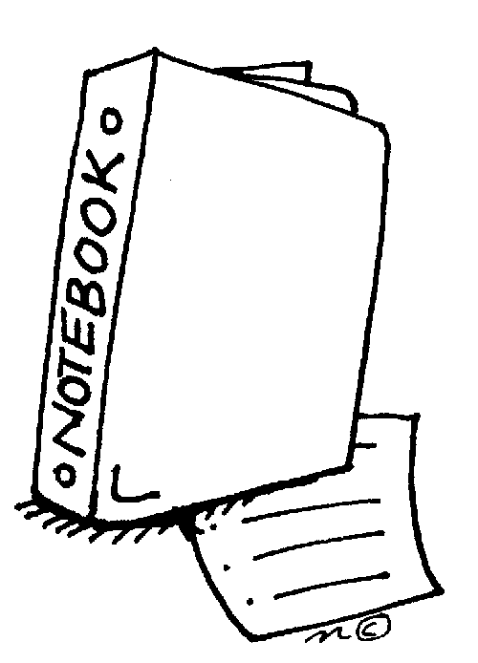

Name: ________________________

Project Due Date: _______________

Project Overview

What is a science fair project?
The science fair project is a long-term project where you will plan, conduct, and share results from your own independent investigation. The project includes complete the pre-planning steps, conducting a science experiment, recording your data in a science notebook, analyzing your data, and creating a tri-fold poster to share your project. You can use this notebook to help you with the project process.

What makes a good project?
The first step to completing a good science fair project is to choose a topic that interests you. Students that have excellent projects do research before they begin. They really understand the science behind their topic and use their knowledge to design an interesting experiment. Another thing that makes a great project is originality. Try to come up with your own question. There are a lot of examples of projects on the Internet. If you are stuck, use these as jumping off points, but try to make the project your own. When you conduct your experiment, do multiple trials. The more data you collect, the better. Also, if something doesn’t go as planned and you have an idea to test why, keep going, this is what scientists do. Finally, you want your poster to be informative, clear, and attractive. You have put a lot of work into planning and conducting your experiment. A well-planned poster will help others see this.

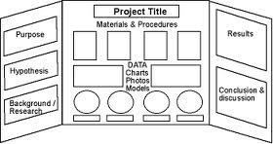
What should my poster look like?
Your poster shares what you learned in your experiment. You will not be able to conduct your experiment during the science fair. In addition to your poster, you should have a science notebook with your research, sources, data, and observations. You can use this packet as your notebook or it could be a spiral notebook that you use while researching, collecting data and making observations.

Science Fair Timeline
Dates | Steps
Topic and Question
Read science magazines, make observations, and find out what interests you. Based on your interests you will develop a testable question. A testable question is a question that can be answered through experimentation.
Research
After you have chosen a question you need to research more about your topic. Come up with some questions related to your topic and search for the answers. Then write a paragraph about what you learned.
Hypothesis
Write a hypothesis that shares your reasoning (don’t forget to include because). Use what you learned doing background research to help you write your hypothesis.
Experiment: Materials and Procedures
Think about how you will conduct a fair experiment by considering the variables you will control. List your materials, including quantities. Write step-by-step procedures so that others could replicate your experiment.
Teacher Approval Form
Before you can begin your experiment your teacher must sign an approval form. The form is on the last page of this notebook.
Collect Data & Make Observations
This is the fun part! Set up your experiment, gather data, and make observations. Take your time and collect accurate data. If you need to adjust your procedures that is fine. You may even come up with another thing you want to test as you learn more! Be sure to run your experiment multiple times.
Data Charts and Graphs
Collecting data and observations throughout your experiment is very important. Record everything! Then use charts and graphs to organize your data so that others will be able to see what you learned.
Conclusion
Share what you learned from your experiment in your conclusion. Your conclusion will be 1 – 3 paragraphs long.
Poster
Your poster should include all the sections of your project in a clear display. The goal of the poster is to teach others about your experiment and what you learned through your investigation.

Topic Brainstorm
In this section you will record ideas about your interests. This will help you to pick a topic and develop a question for your science fair project. Fill in each text box.
1. What do you like to do outside of school? (examples: art, theater, sports, build things, cook, etc.)
2. What is your favorite thing you have done related to science? (examples: experiments, tv shows, museums, etc.)
3. Take the science interest survey on the next pages. List the science disciplines that you are interested in.
4. Free Write: In the space below write about the topics you think you might be interested in for the science fair. What ideas do you have right now?
Science Interest Survey

Directions: Answer each question with “yes”, “no” or “kinda”

- Do you like building or repairing machines?
- Do you enjoy gardening and working with plants?
- Are you curious to understand things like gravity and magnetism?
- Does observing the behavior of different people fascinate you?
- Do you enjoy working on computers or learning about how computers work?
- Do you like to go hiking or snorkeling so that you see different animals in their
natural environment?
- Do you enjoy learning about the forces of nature like weather and earthquakes?
- Do you enjoy learning about memory and how our brain works?
- Are you curious about the way different animals grow, develop, and live?
- Are you interested in science fiction stories involving faster than light travel and
"beams" that do amazing things?
- Do you want to understand more about how people are affecting the environment?
- Do you enjoy learning about outer space and astronauts?
- Do you enjoy learning about lakes, rivers, the ocean, and beaches?
- Have you built inventions or other things for fun and not a school project?
- Do you enjoy learning about chemicals and things that bubble, fizz, or explode?
- Do you enjoy discovering new ways to recycle, restore, or re-use old stuff?
- Do you like to go on drives or hikes specifically so that you can see interesting
mountains, rock, or caves?
- Do you enjoy watching or participating in sports?
- Do you like learning about what makes us healthy and what makes us sick?
- Are you interested in how to build roads, bridges, and buildings?

What kinds of science are you interested in?

Directions: Circle the numbers that you answered “Yes” to on the other side.
These are the kinds of science that you are interested in!

1. Engineering: Learning about how to build and design things, how things work
2. Plant biology: Learning about how plants grow and change
3. Physics: Learning about energy and forces, how things move and change
4. Psychology: Learning about how people and animals think and behave
5. Computer science: Learning about how computers and computer software works
6. Zoology: Learning about different kinds of animals
7. Meteorology: Learning about weather and how it changes
8. Psychology: Learning about how people and animals think and behave
9. Zoology: Learning about different kinds of animals
10. Optics (physics): Learning about how light behaves and interacts
11. Environmental science: Learning about ecosystems, living and nonliving things
12. Astronomy: Learning about outer space and our solar system
13. Oceanography: Learning about the oceans and other bodies of water
14. Engineering: Learning about how to build and design things, how things work
15. Chemistry: Learning about what matter is made of and how they change
16. Environmental science: Learning about ecosystems, living and nonliving things
17. Geology: Learning about the earth and what it is made of
18. Sports science: Learning about the physics of games and the biology of athletes
19. Biology: Learning about living things and how they grow and change
20. Engineering: Learning about how to build and design things, how things work

Now list the types of science you are interested in box #3 of the Topic Brainstorm page.

Question
Your science fair question needs to be a testable question. This means that in order to answer your question you will have to conduct an experiment. Think about your question idea. Will you be conducting an experiment or just doing a demonstration? For example, growing a plant is just a demonstration, but determining how the amount of fertilizer in the soil affects the height of a plant is an experiment.

Most testable questions will fit into one of these question frames. Can you put your idea into one of these frames?

- What is the effect of ________________ on _________________?
- How does _______________ affect ____________________?
- Which/What ______________(verb) ___________________?

Excellent questions are creative and meaningful. If you found your question on the Internet, ask yourself if there is a way to make the question your own. When you develop your question, you also want to make sure your idea is meaningful. What is the purpose of your project? Who might it help?

1. Write your question in the space below:
Research
2. A great way to get ideas for your science fair project is to share your question with others. In the space below record ideas or questions that others have shared with you about your project.
Before you plan your experiment it is very important that you understand the science behind your topic and your question. The more you know, the better your experiment will be. One way to do this is to think of 3 questions that relate to your science fair topic and question. For example, if your experiment is about plants, you will need to know what plants need to survive and why they need those things.
In the spaces below record the questions you want to answer through research. Then research the answers to the questions. Be sure to record your source (website, book, etc.) in the works cited section. You will include these sources on your final poster.
Question 1:
Answer:

Works Cited:
Question 2:
Answer:

Works Cited:
Question 3:
Answer:

Works Cited:
Background Research Paragraph
Synthesize the information that you learned while researching your topic to write a background research paragraph. The paragraph should explain the science concepts that are related to your topic and question. You will use the information in this paragraph to help you form a hypothesis and design your experiment.

In the space below write your background information paragraph.
Hypothesis
A hypothesis is more than just an educated guess. A hypothesis is a probable answer to your question; it is based on the research that you have just completed. A good hypothesis shares what you plan to change, what you predict will happen, and your reasoning for your prediction. Here is an example of a good hypothesis:

If I give different amounts of fertilizer to bean plants, then the plant that receives the most fertilizer will grow the tallest because fertilizer provides plants with nitrogen. Nitrogen is an important nutrient for plants because it is used by plants to grow new stems and leaves.

Your hypothesis might be one or more sentences long. Be sure that your hypothesis is a probable answer to your question, and gives your reader information about how you will conduct your experiment. Use the hypothesis frame below to help you do that.

If ________________, then __________________ because______________.
1. Write your hypothesis in the space below:

Experiment: Materials and Procedures
Design an experiment that will allow you to answer your question. Before you start, think about what you are changing in the experiment (your independent variable), what you will measure in the experiment (your dependent variable), and what factors you will keep the same in order to design a “fair” experiment (controlled variables).

For this section you need to list your materials and write procedures. Your materials should include quantities. Your procedures can be written as a paragraph or in step-by-step form. Be specific, after reading your material list and procedures someone else should be able to reproduce your experiment.
Write your list of materials below:
Write your procedures below:

STOP

STOP: Before you start your experiment be sure that your teacher has signed and collected your science fair approval plan (the last page of this packet).

Collect Data & Make Observations
Before you begin your experiment, it is a good idea to make a plan for how you will organize the data that you collect. Think about what you will be changing and what you will be measuring. Think about how much data you will collect. How often will you collect data and for how long? The more data you collect, the better your results will be. Consider doing more than one trial. This means you might end up conducting your experiment 3 or 4 times.

In the space below, create a table that you can use to record data. To do this answer the following questions:
- What is your independent variable (what you will change)? _____________________________________________________
- What is your dependent variable (what you will measure)? _____________________________________________________
- How many trials will you conduct or how many samples will you use?
_____________________________________________________

Data Table:

Observations
While you are conducting your experiment you will also want to record observations. Observations can be photographs, drawings or written descriptions. Be sure to record the date for each observation that you make. Below is a sample observation.
Date: 11/21/14
All of the plants have sprouted. The plants that have no fertilizer have 2 green leaves each. The plants that have 5 mL of fertilizer have 2 green leaves each. Two of the plants with 10 mL of fertilizer have 2 green leaves each. One of the plants with 10 mL of fertilizer has one green leaf and one white leaf.

The next few pages are blank so that you can record the observations you make while conducting your experiment. You can also choose to record your observations in a spiral or composition notebook.

Observations cont’d

Observations cont’d

Observations cont’d

Graphs
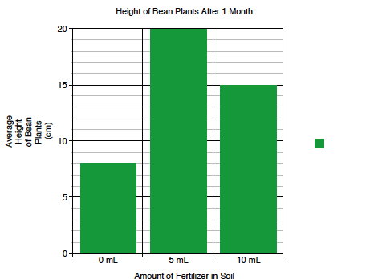
The purpose of a graph is to create a visual display of your data. Graphs are helpful because they show patterns. The type of graph that you make will depend on the data that you want to display. Bar graphs are best for discrete data, e.g. comparing objects or events. Line graphs are best for continuous data, e.g. changes over time. Below is a sample of a bar graph and a line graph.

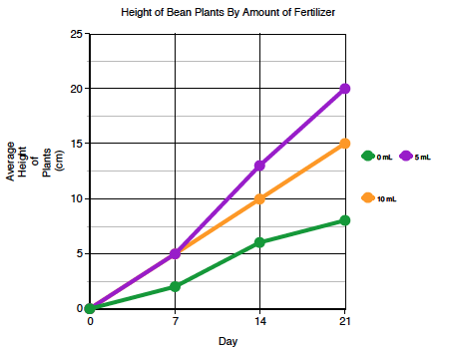

When you make a graph be sure that it has a title and that both the x- and y-axis are labeled. On the next page create your graph or make one on-line and paste it in this notebook. Click here or do a Google search for the Create A Graph website.

Data Charts & Graphs cont’d

Explain what your graph shows.

Conclusion
The conclusion is a place for you to share what you learned from conducting your experiment and analyzing your data. Your conclusion should be one to three paragraphs long. In your conclusion you should:

- Evaluate your hypothesis. Was your hypothesis correct?
- Explain what you found out.
- Use data to support your findings.
- Infer why your experiment turned out as it did.
- Explain why your findings are important. Who might benefit from what you learned?

Display Board
Write a rough draft of your conclusion in the space below.
Your display board should demonstrate all of the hard work that you have put into your science fair project. Don’t wait until the last minute! Use the information that you have recorded in this science fair notebook to help you decide what to write on each section of your board. The picture shows one example of how to set up your board. Your board may look a little different, depending on the experiment that you conducted.
Science Fair Notebook

SECTIONS FOR THE DISPLAY BOARD
Question/Purpose: An excellent question is interesting, creative, and worded scientifically.

Research: This section should include why you chose this project or what makes it interesting. Also include the information you learned about your topic by doing background research.

Hypothesis: An excellent hypothesis provides a possible answer to your question. The hypothesis is based on your background research.

Materials and Procedures: In this section you explain what you did to test your hypothesis. Include your materials and procedures. Be specific so that others understand what you controlled to make a fair experiment. If you did multiple trials be sure to include that in your procedures. Pictures are very appropriate in this section, but your pictures should not show people’s faces.

Data and Observations: Include a chart or graph to represent the data that you collected.

Results: Explain what your data shows. Describe patterns, trends, and any data that is unexpected.

Conclusions: A good conclusion will be 1 – 3 paragraphs long. Your conclusion should share what you learned through your investigation and why your findings are important.

Science Fair Notebook: Your science notebook should include the research you did for the project, a list of sources that you used for research, and all of the data and observations you recorded while conducting the experiment.

