6th Grade Strand 1: Models of Orbital Motion

Lesson Description:
In this lesson students use several different types of models to gain an understanding of how the force of gravity on an object and the object’s forward velocity (inertia) influence orbital motion.

Standard(s):
6.1.2 Develop and use a model to describe the role of gravity and inertia in orbital motions of objects in our solar system.

6.1.3 Use computational thinking to analyze data and determine the scale and properties of objects in the solar system. Examples of scale could include size and distance. Examples of properties could include layers, temperature, surface features, and orbital radius. Data sources could include Earth and space-based instruments such as telescopes and satellites. Types of data could include graphs, data tables, drawings, photographs, and models.

Practice(s)  Describe how students are engaged in a few practices. | Crosscutting Concept(s)  Explain how crosscutting concept(s) provide a lens for the students | Disciplinary Core Idea(s)  State the big ideas students will use to explain the phenomenon.
Develop and use a model to describe phenomena.  Construct, analyze, and/or interpret graphical displays of data to identify linear and nonlinear relationships. | Models can be used to represent systems and their interactions.  Cause and effect relationships may be used to predict phenomena in natural or designed systems. | The solar system consists of the sun and a collection of objects, including planets, their moons, and asteroids that are held in orbit around the sun by its gravitational pull on them. This model of the solar system can explain eclipses of the sun and the moon.

Lesson Time Frame  This lesson will take several class periods. Suggested scheduling is as follows. | Lesson Materials
Day 1: Engage solar system animation and Explore 1 string and washer model  Day 2: Explore 2 bowling ball and lycra model and Explain simulation and reading  Day 3: Elaborate comparing orbital velocities  Day 4: Evaluate explanation of why the planets orbit the Sun | Per group:  sturdy straw (6”), string (20”), 2 safety pins, 4 small washers, safety goggles  Per class:  lycra (45”X45”), bowling ball, variety of small balls  Per student:  Solar System Fact Sheet (available in lesson folder)  computers for HTML-based simulation
Models of Orbital Motion Storyline
Driving Question / Anchor Phenomenon
Why do the planets orbit the Sun?

Phenomenon-driven question* | How students will make sense of phenomenon through practices | Conceptual understanding(s)
Engage:  What is the relationship between the Sun and the planets? | Ask questions about a simulation that shows the planets orbiting the Sun. | The planets orbit, or revolve around the Sun.
Explore 1:  What forces are acting on planets when they orbit the Sun? | Use a model made from washers, string, and a straw to explore how gravity and forward velocity can cause one object to orbit another object. | Less massive objects orbit more massive objects.  The Sun’s gravity pulls on the planets.  The planets need to have forward velocity to stay in orbit.
Explore 2:  How could a planet crash into the Sun? How could a planet escape into space? | Develop and use a model made from to demonstrate that forward velocity is needed for an object to stay in orbit in a system. | If a planet’s forward velocity increased it would escape into space. If a planet’s forward velocity decreased it would crash into the Sun.
Explain:  How do the planets continue to stay in orbit? | Analyze a computer simulation in order to model how gravity and an object’s forward velocity must be balanced. | The force of gravity on a planet and the planet’s inertia must be balanced in order for a planet to stay in orbit.
Elaborate:  Why do the inner planets travel faster than the outer planets? | Use a model to explore the relationship between distance from the Sun and orbital velocity. Analyze data to compare the orbital velocities of the planets. | Planets that are closer to the Sun experience more gravitational force and need a faster forward velocity to stay in orbit. Planets that are farther from the Sun experience less gravitational force and need a slower forward velocity to stay in orbit.
Evaluate:  Return to Driving Question:  Why do the planets orbit the Sun? | Construct an explanation for why the planets orbit the Sun using words and/or diagrams. | The reason the planets orbit the Sun is due to gravity and inertia. Planets are pulled toward the Sun because of gravity. Planets also have forward velocity, or inertia. As a planet is pulled towards the Sun it keeps moving forward. This makes the planet travel in a circular orbit around the Sun. If a planet’s forward velocity were too fast it would escape the Sun’s gravity and fly into space. If a planet’s forward velocity were too slow it would be pulled by the Sun’s gravity and crash into the Sun.
* Note: These questions may need to be modified based on the questions students develop throughout the unit.

Modeling Orbital Motion 5E Lesson

Engage: What is the relationship between the Sun, the planets, and moons?
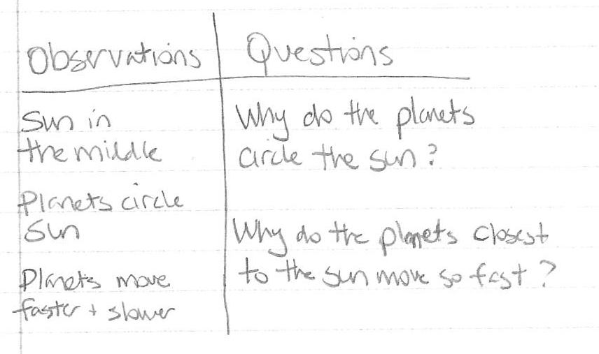
Start the lesson by having students watch an animation that shows the planets orbiting the Sun and/or the moon orbiting Earth. As students watch the simulation, they should make observations on a t-chart. On one side of their t-chart students should record observations of the animation, on the other side of the t-chart students should record questions that they have. Encourage students to share their observations and questions in a small group, then have each group share a question that they have about motion in the solar system. Use students questions to guide them to the driving questions of: Why do the planets orbit the Sun?
Any solar system animation can be used. The following animation shows the inner planets and Jupiter orbiting the Sun from several different perspectives.
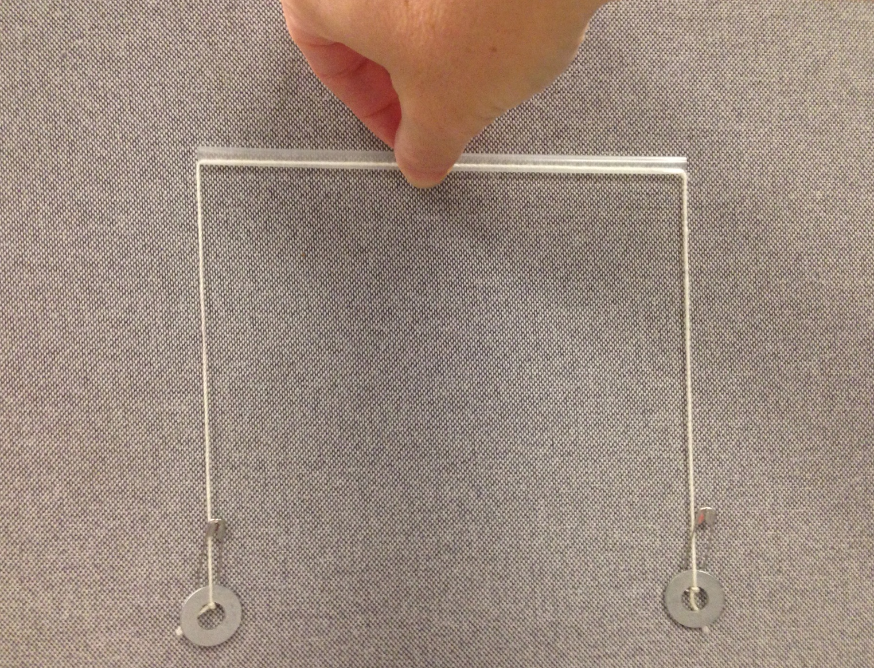
https://www.youtube.com/watch?v=9R5P9Y9gRYY

Explore 1: What forces are acting on planets when they orbit the Sun?
To introduce the pull of the Sun’s gravity on a planet and a planet’s forward velocity, or inertia, students will explore a simple string and washer model. Give each small group one model. First, have the students practice with the model. Tell the students to hold the straw horizontally and then balance the two sides. Next have the students hold the straw vertically and make the top washer spin around by making a circular motion with the straw. The goal is to control the speed of the spinning washer so that the washer on the bottom does not move up or down. Once all students can do this, they are ready to explore this model as a model of a Sun and planet system.
String & Washer Model
To build the model, thread a 20 inch piece of string through a 6 inch straw (be sure that the straw is fairly strong). Tie a safety pin to each end of the string. Attach a small washer to each end of the string by stringing the washer on one end, then opening the safety pin and looping some string through the safety pin. This will secure the washer on the string without having to tie a knot.

Explain to students that they are going to use the model to learn more about why the planets orbit the Sun. The model allows them to explore forces and motion. Discuss the model, and ask students what they might need to do if they want the bottom washer (when the straw is held vertically) to represent the Sun. The Sun is much more massive than Earth, but in this model use 3 washers on one side to represent the Sun and one washer on the other side to represent the planet. Have students add 2 more washers to the Sun side of their model. Let students explore the model and record any observations that they make. Ask students questions to guide their exploration:
- With more mass on the Sun side of the model now, do you need to spin the planet side of the model faster or slower than before?
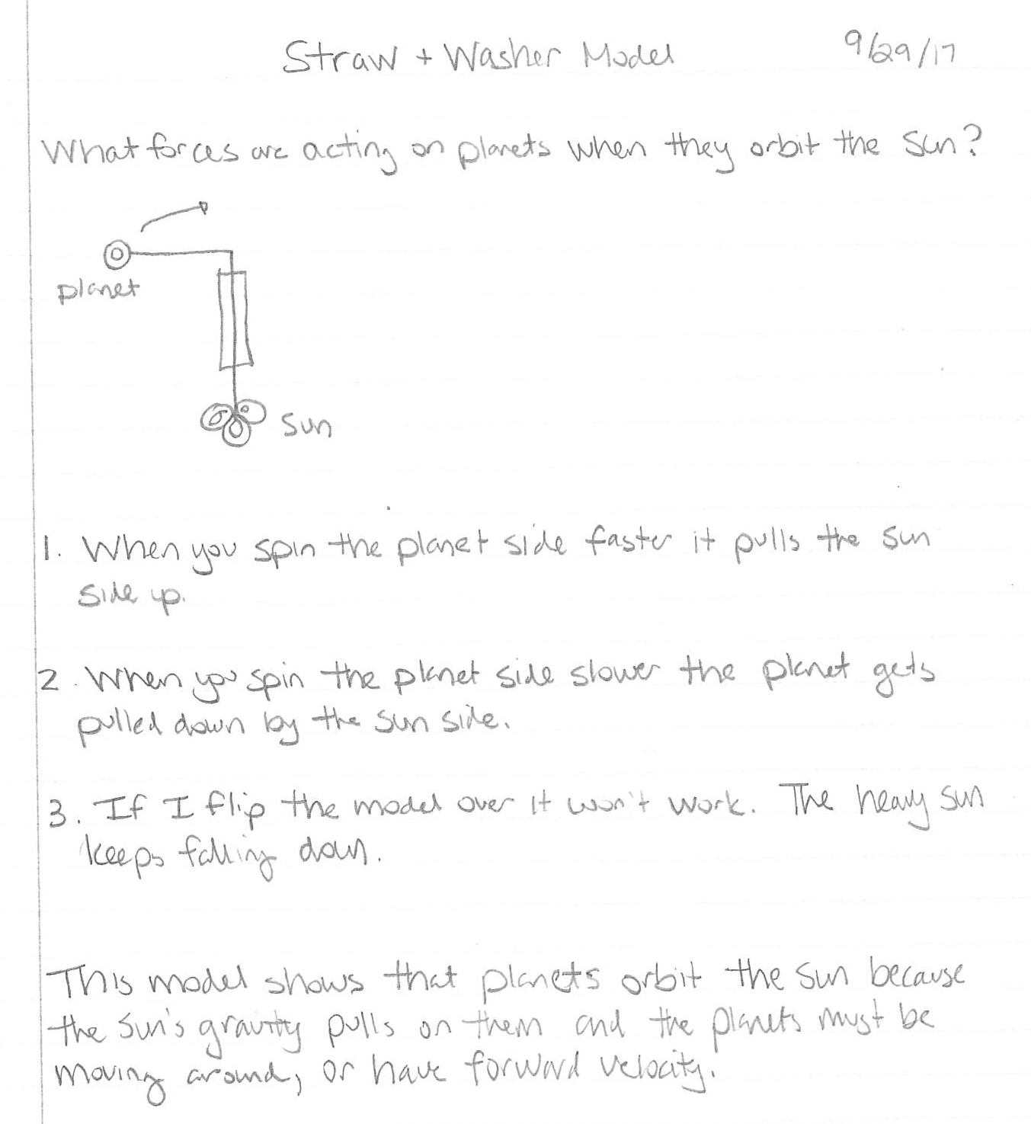
- What happens when you spin the planet side faster? Slower?
- What happens if you flip the model over, could the Sun (the more massive side) orbit the planet (the less massive side)?
Lead the students in a discussion of their observations. Key points that should come out of this discussion is that the Sun side of the model pulls on the planet, the planet needs to be moving in order to stay in orbit. If the planet moves too slowly it is pulled towards the Sun side (with the help of gravity in the classroom). If the planet moves too quickly it pulls up on the Sun, or starts to move away from the Sun. Also, the less massive object always orbits the more massive object. Use these observations to introduce the idea that because the Sun is more massive than a planet it has more gravitational pull on the planet than the planet has on the Sun. And that the motion a planet needs to stay in orbit is referred to as the planet’s forward velocity.

Explore 2: How could a planet crash into the Sun? How could a planet escape into space?
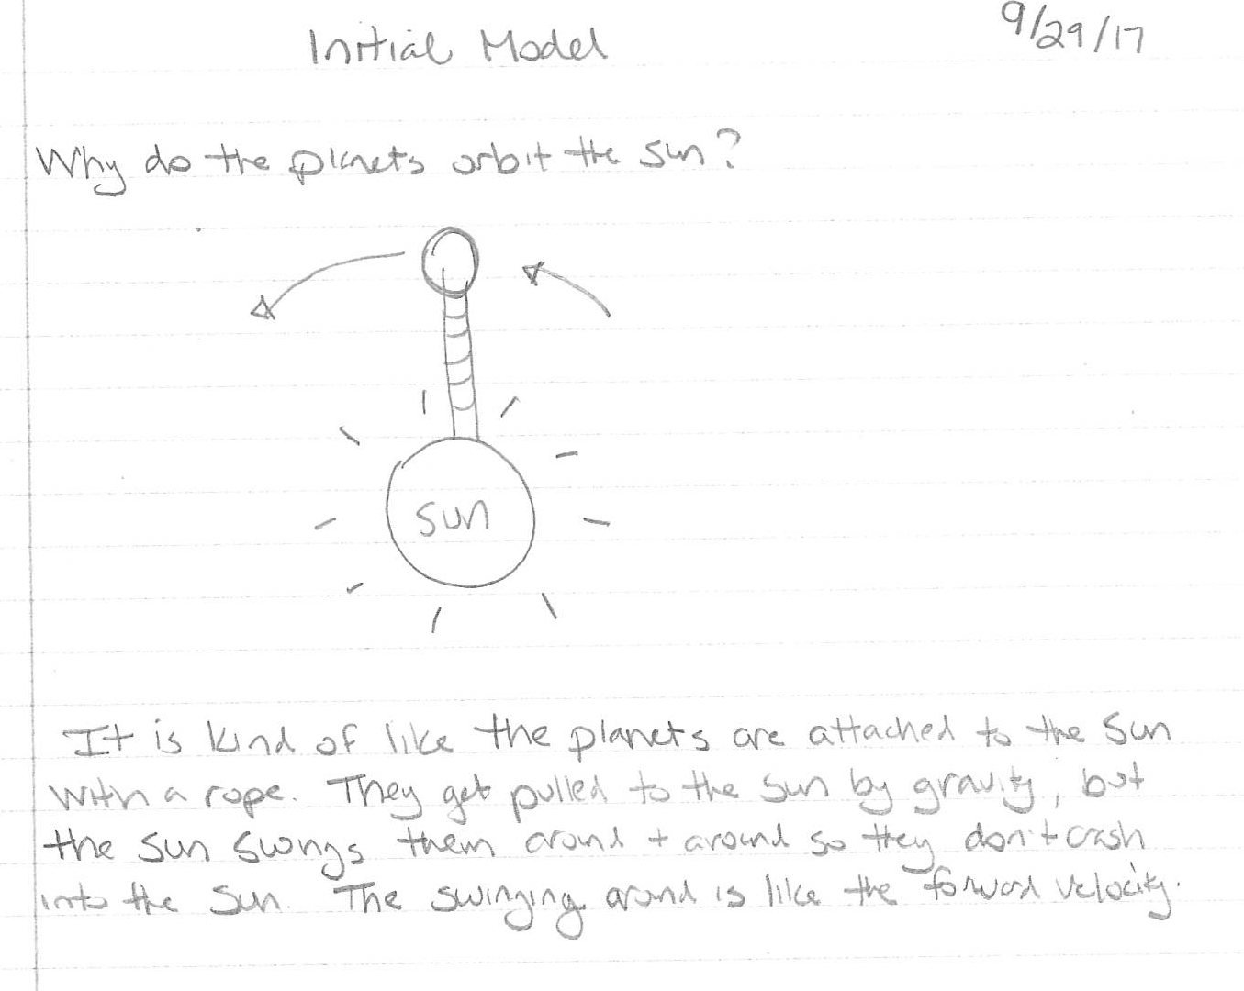
Using the string and washer model, students observed that if a planet moves too fast it will escape the Sun’s gravity and that if a planet moves too slow it will be pulled towards the Sun. In the next model, students will simulate this by rolling small balls towards a bowling ball, and try to find just the right amount of forward velocity so that the ball orbits the bowling ball. To construct the model, have about 8 students stretch and hold a piece of lycra (material that stretches in all directions). Place a bowling ball on top of the lycra. The students will need to hold and pull to keep the lycra taut. Invite other students to roll small balls (soft toy balls, rubber bouncy balls, golf balls, etc.) towards the bowling ball. Their goal is for the small ball to orbit the bowling ball, with enough practice students should be able to find a speed and curve that will allow the small balls to orbit the bowling ball a few times before it is pulled towards the bowling ball. If students roll the small balls too slowly they will roll into the bowling ball. If students roll the small balls too quickly they will roll off the edge of the lycra.
In discussing the model, and what students noticed, be sure to define the system in this model. The bowling ball represents the Sun, the lycra represents space, and the small balls represent planets. The force that the students apply to the small balls to give them forward velocity and the force of gravity that pulls the small balls towards the slightly lower bowling ball is a part of the model system as well.
After students have explored the model, have them write about their experiences with both models construct an initial model to explain why planets orbit the Sun. Encourage students to describe the role of gravity and a planet’s forward velocity in keeping the planets in orbit.

Explain: How do the planets continue to stay in orbit?
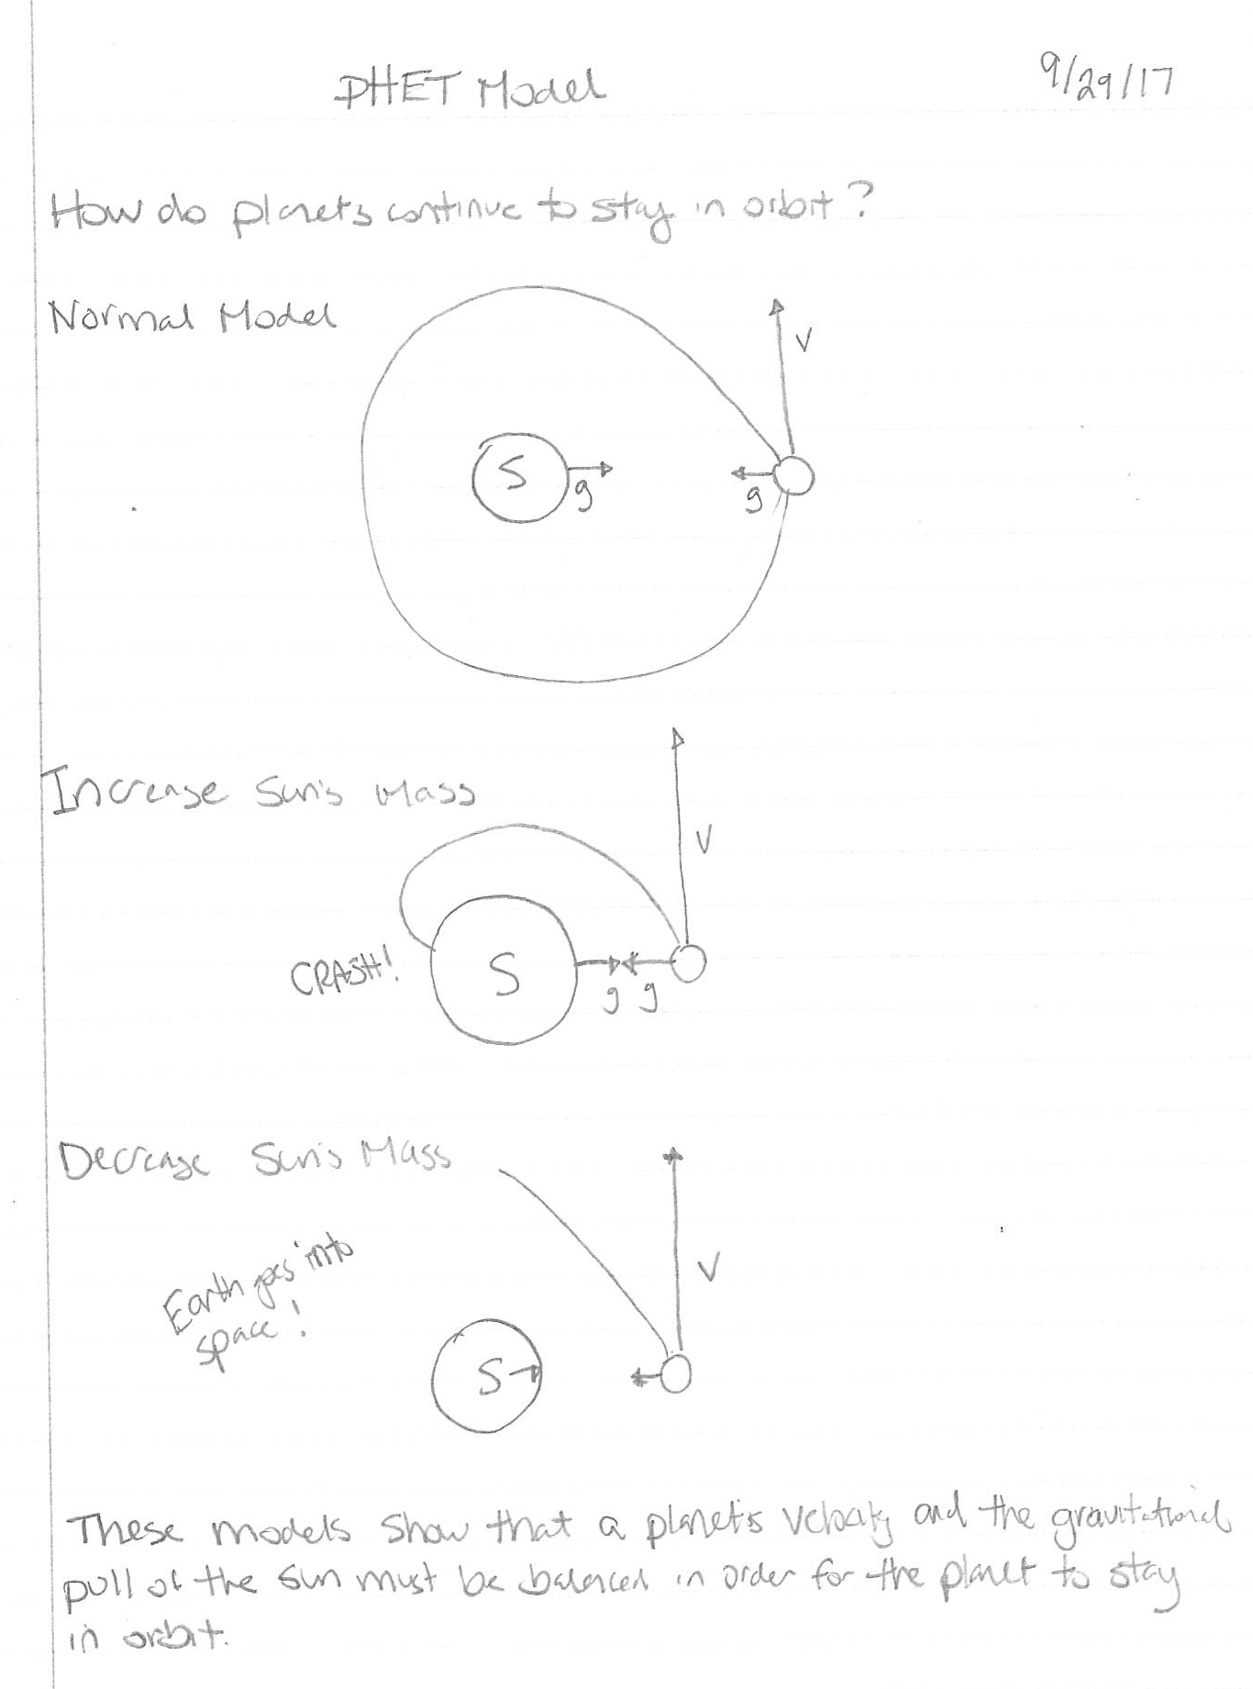
During the explain section of the lesson students build an understanding of how the force of gravity must be balanced with the planet’s forward velocity, or inertia, in order for a planet to stay in orbit. Have students begin to explore this idea by using a HTML-based PHet simulation, Gravity and Orbits, and reading about an analogy for orbiting objects. In the simulation students will observe the interaction between gravity and velocity as the Earth orbits the Sun. After observing the Earth and Sun system without changing gravity, students can then explore what happens to the Earth if the Sun is more massive and has a greater gravitational pull on Earth, what happens when the Sun is less massive and has a smaller gravitational pull on Earth, and what happens when the Earth is orbiting the Sun and gravity is “turned off”. (Note: To make the simulation work, students will need to hit reset, change the gravity variable, and then press play. If they do not reset the system too many changes will occur at once.) Then, through the reading students will think about how a football traveling fast enough could orbit Earth if it were to move forward as it fell towards Earth.

PhET Simulation: Gravity and Orbits | https://phet.colorado.edu/en/simulation/gravity-and-orbits
Reading: Why do the planets orbit the Sun? | http://curious.astro.cornell.edu/about-us/57-our-solar-system/planets-and-dwarf-planets/orbits/243-why-do-the-planets-orbit-the-sun-beginner

After students have used the simulation and read the article, draw a model of the Earth and Sun on the board (see example). Ask students to explain the model that you have drawn by asking students to analyze what the components of the model represent. Discuss how the force of gravity must be balanced by the planet’s inertia, it’s tendency to continue to travel forward. As the planet is pulled towards the Sun it also moves forward. When these motions are balanced, it will make the planet travel in a circular path, or orbit, around the Sun. To extend students thinking draw a larger arrow to represent gravity and ask them what will happen [The planet will crash into the Sun]. Then draw a larger arrow to represent the planet’s forward velocity and ask them what they think would happen. [The planet would escape into space]. To reinforce the idea of inertia, ask students what would happen to the planet if the Sun had no gravitational pull on the planet. The planet would keep moving forward in a straight line because there is no friction in space to stop its forward motion. The tendency of an object to keep moving at the same speed and in the same direction is inertia.

Encourage students to add diagrams and/or more information to the explanations that they have written for why the planets orbit the Sun.

(Teacher Note: If you have the software Universe Sandbox (free from a Clark Planetarium Workshop) you can do several simulations with the solar system to show how gravity and inertia affect planets’ orbits. These simulations would fit well in the Explain phase of the lesson.)

Elaborate: Why do the inner planets travel faster than the outer planets?
If students did not notice that Mercury was traveling faster than Mars or an outer planet in the solar system animation from the engage section of the lesson, show this again, asking students to observe the forward velocity of the planets. Explain to students that they will use a model and analyze data to explore the orbital velocity of different planets and develop a claim for why they think the planets travel at different speeds.
First, have students return to the string and washer model. Ask them to model a planet that is close to the Sun. To do this, students will need to pull the planet washer closer to the top of the straw. Have students make this close planet orbit the Sun. Then ask students to model a planet that is farther from the Sun. To do this, students will need to pull the planet washer farther from the top of the straw. In making the planets orbit, students should notice that the closer planet spins faster than the farther planet.
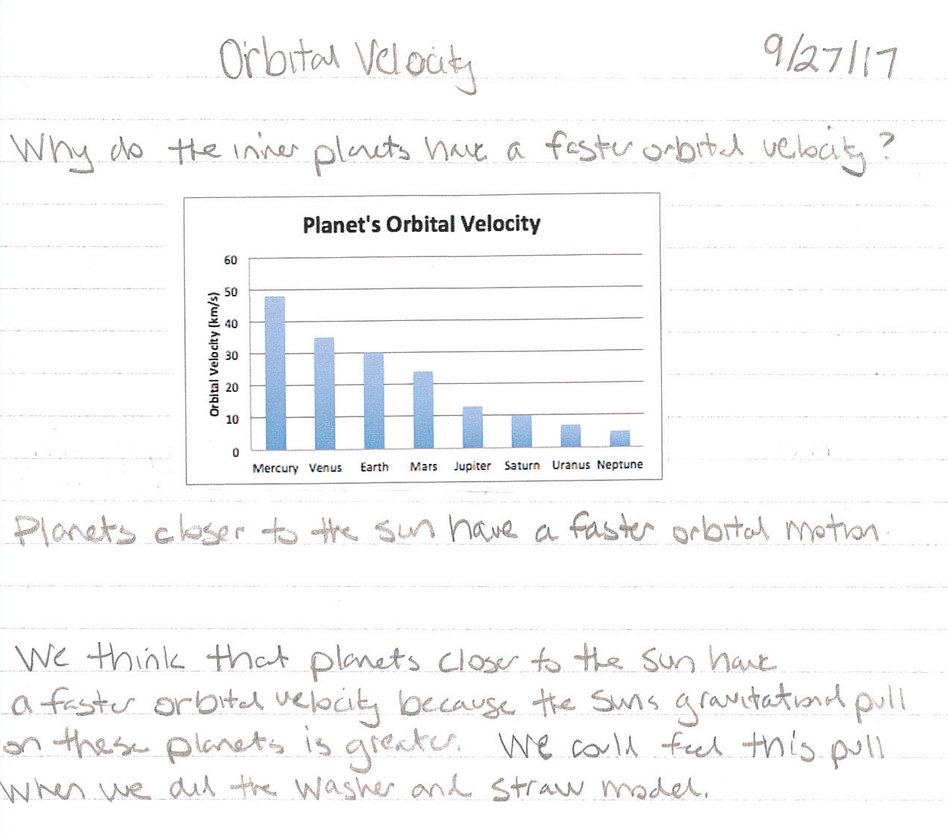
Second, have students graph the orbital velocity of the planets (km/s) in order from closest to farthest from the Sun. Students can gather the data from the Clark Planetarium Solar System Fact Sheet. After graphing this data, students should be able to describe the trend that the orbital velocity decreases as the distance from the Sun increases.
Challenge groups of students to develop a claim for why the planets that are closer to the Sun have a faster orbital velocity than the planet’s that are farther from the Sun. Encourage students to return to the arrow model of the Sun and Earth that they analyzed during the explain section of the lesson to help them reason that planets that are closer to the Sun experience a greater gravitational pull, and thus need a faster forward velocity to stay in orbit. Planets that are farther from the Sun experience a smaller gravitational pull and need a slower forward velocity to stay in orbit.

Evaluate: Why do the planets orbit the Sun?
Have students return to the initial explanations for why the planets orbit the Sun that they wrote during the explore and the explain phases of the lesson. Ask students to revise these explanations to develop a more thorough explanation for why the planets orbit the Sun. To improve their explanations encourage students to explain how the relationship between the force of gravity on a planet and the planet’s forward velocity, or inertia, affects whether or not the planet stays in orbit. Also, encourage students to explain what would happen if the relationship between the force of gravity and a planet’s forward velocity changed (e.g. gravity or forward velocity increased). A sample student response and rubric are provided below.

Sample Student Response

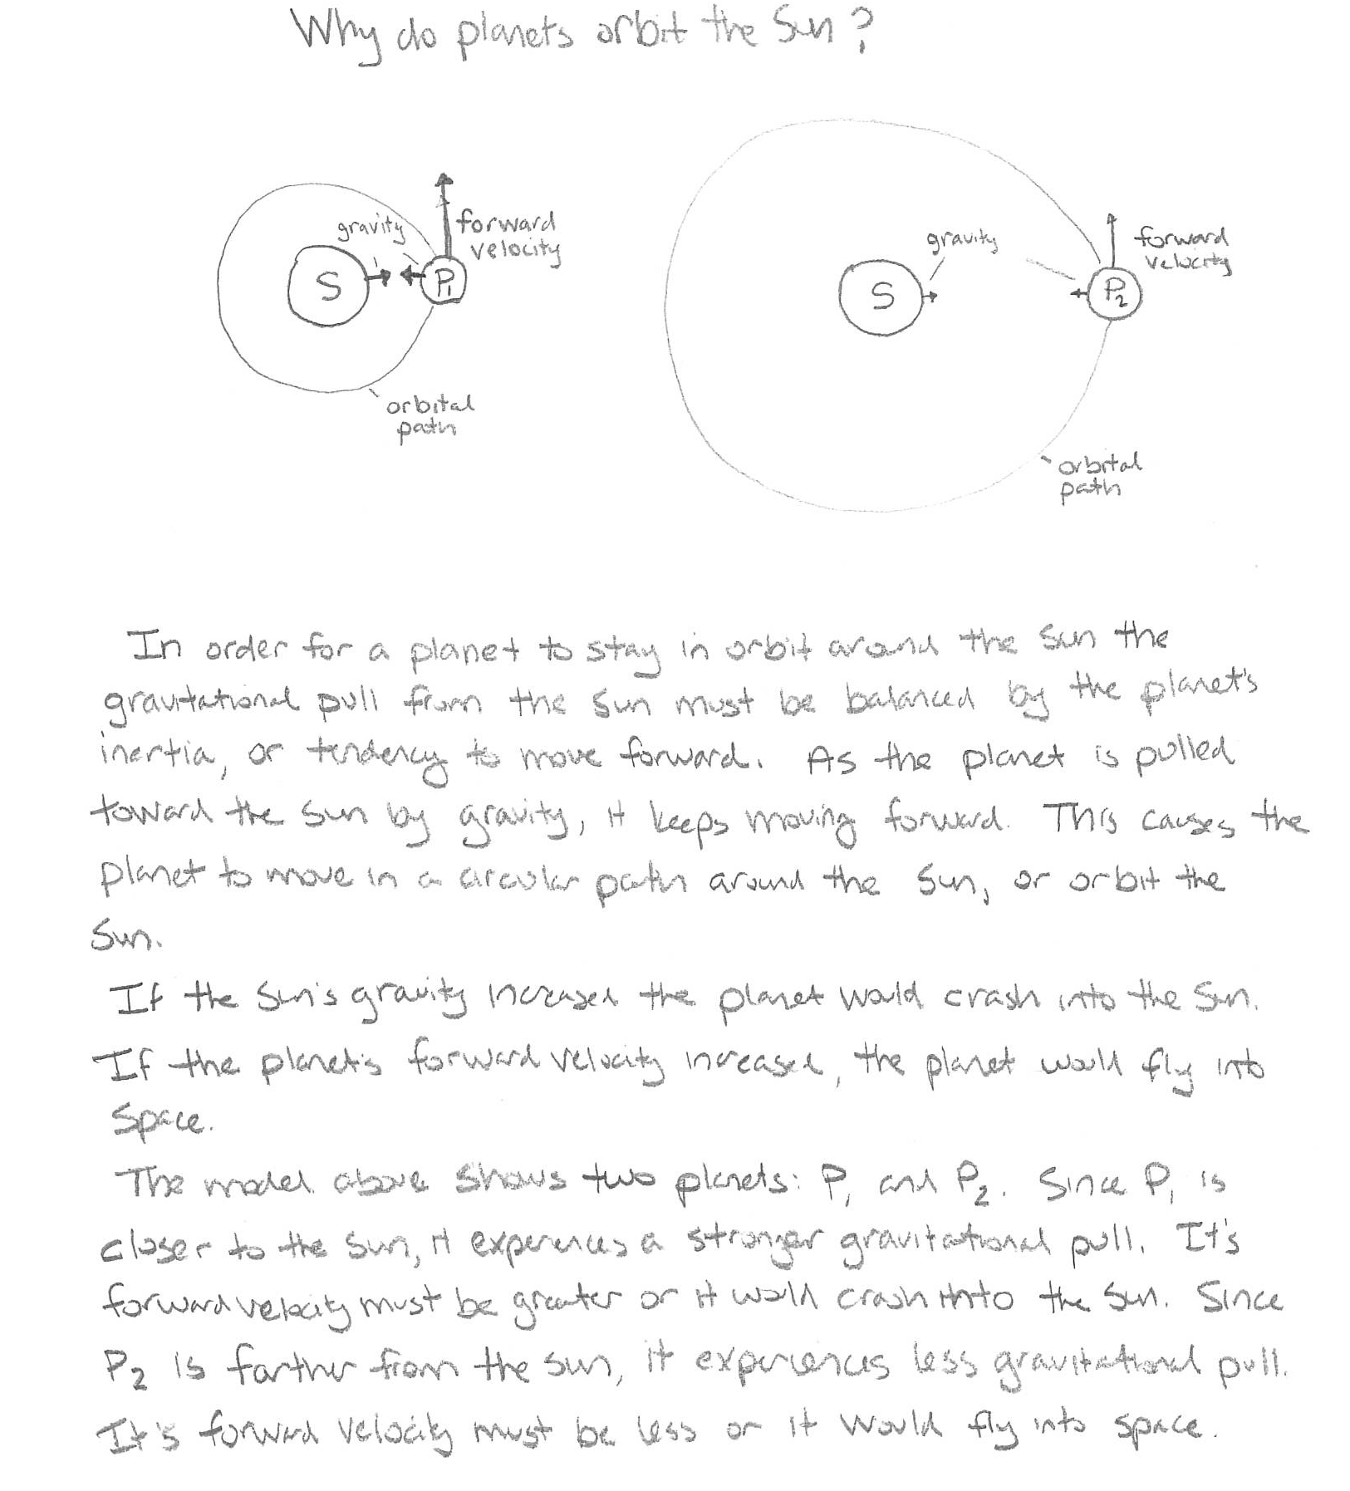

Sample Rubric

Scoring Criteria | 1 | 2 | 3 | 4
Model of Orbital Motion | The model and explanation includes errors and/or does not represent the Sun-planet system.  Diagrams are unclear. | The model and explanation is generally accurate and names gravity and inertia as factors in the Sun-planet system.  Diagrams are somewhat clear, but not labeled. | The model and explanation demonstrates an understanding of the roles gravity and inertia in the Sun-planet system.  Diagrams are clear and labeled. | The model demonstrates a deep understanding of the roles of gravity and inertia in the Sun-planet system and explains how changes to gravity and inertia (forward velocity) would affect the system.  Diagrams are clear, detailed, and labeled.

